

**The Coffee & Cake**

|  |  |  |
| --- | --- | --- |
| **Supervisor:** | *LÊ THANH NHÂN* | |
| **Semester:** | *II* | |
| **Batch No:** | *T1.2206.E1* | |
| **Group No:** | *04* | |
| **Order:** | **Full name** | **Roll No.** |
| *1.* | *Nguyễn Đình Nam* | *Student1387805* |
| *2.* | *Trần Hoàng Tú* | *Student1387806* |
| *3.* | *Trần Lê Huy* | *Student1387823* |

***Month****:03* ***Year****:2023*



This is to certify that

|  |  |
| --- | --- |
| **Mr.** | **NGUYỄN ĐÌNH NAM** |
| **Mr.** | **TRẦN HOÀNG TÚ** |
| **Mr.** | **TRẦN LÊ HUY** |

Have successfully Designed & Developed

|  |  |  |
| --- | --- | --- |
|  |  |  |
| **The Coffee & Cake** | | |

Submitted by:

|  |
| --- |
| **Mr. LE THANH NHAN** |

Date Of Issue:

|  |  |
| --- | --- |
|  |  |

Authorized Signature:

|  |  |
| --- | --- |
|  |  |
| **Content** | | | |

Content

Acknowledge

Synposis

Review1 (Page 1)

Review2 (Page 7)

Review3 (Page 21)

Testting Document (Page 30)

Final Checklist (Page 31)

Tasksheet (Page 32)

|  |
| --- |
| **Acknowledge** |

As we understand that the Project is a step-by- step learning environment that closely simulates the class-room and Lab based learning environment into actual implementation. It is a project implementation at your fingertips!! An electronic, live juncture on the machine that allows you to.

* Practice step by step i.e. laddered approach.
* Build a larger more robust application.
* Usage of certain utilities in applications designed by user.
* Single program to unified code leading to a complete application.
* Learn implementation of concepts in a phased manner.
* Enhance skills and add value.
* Work on real life projects.
* Give a real life scenario and help to create applications more complicated and useful.
* Mentoring through email support.

We would like to send a great thank to our professor, Mr Le Thanh Nhan and others student for the adorable supports during the time in project.

Beside several mistakes we had made in the project, we hope to have more opportunities to widen our knowledge in web developing world.

We also thank you so much for your information and the “demo” project from India APTECH to help us get more reality experience in this project. Since we have gained more experience from this project, we will not stop learning any thing as much as we can to be more successful in the future.

Your Sincerely,

Team Group 04.

|  |
| --- |
| **Synposis** |

The Objective of this program we aim is to give a sample project to work on real life projects. These applications help us build a larger more robust application.

The objective is not to teach us front-end or back-end technology but to provide us with a real life scenario and help us create basic applications using the tools.

Hence, we can revise the chapters before we start with the project.

This project is meant for students like us who have completed the module of Semester II, as well as special subjects those are Java and PHP. These programs should be done in the Lab sessions with assistance of the faculty if required.

The website (in this project) is a world that brings everything about the potteries and crockeries into your experience.

It is very essential for us that will have a clear understanding of the subject. We think we should go through the project and solve the assignments as per requirements given.

**Review 01**

|  |
| --- |
| **Problem Definition** |

The Coffee & Cake is a simple web application designed to help users order and pay for coffee and cakes online. The app allows users to select products by category and view product details, including price and description. Users can order and pay online using popular payment methods such as credit cards or e-wallets. After placing an order, the user will receive a confirmation message about his order. Application administrators can manage products, orders, and customer information. The goal of the application is to provide a simple and convenient user experience when ordering online and to help administrators manage their business more easily. Based on the needs outlined in the project, we have designed an application that will provide the following features and functions:

Based on the needs outlined in the project, we have designed an application that will provide the following features and functions:

* Users can view products by name or description
* Users can place orders for products from the page.
* Allows users to add products to their cart and place orders by entering delivery address information and selecting payment methods.
* Users can change the quantity of products or remove products from the cart.
* Users can view history order.

An Admin Control Panel (ACP) that support about management system:

* Administrators the ability to add, deactivate, update product information quickly and accurately
* Administrators the ability to manage
* Administrators the ability report statistics.

The Role of User and Admin:

1. User:
   * Can register as a member and manage personal account.
   * Can view and buy products.
   * Can view their orders.
2. Administrator
   * Can add / edit / deactivate products and categories.
   * Can view customer’s information.
   * Can view all orders and approve orders.
   * Can view report statistics.

|  |
| --- |
| **Customer Requirements Specifications** |

|  |
| --- |
| **User:** |
| **Input:** |
| * Member data for sign in. * Add product to cart |
| **Process:** |
| * Process user’s orders. * Process information login user's |
| **Output:** |
| * Notification of successful registration / failure. * Notification of successful making order. * Order’s information. |

|  |
| --- |
| **Webmaster:** |
| **Input:** |
| * Administrator login data. * Product and category information to add / edit. * Order information to be search |
| **Process:** |
| * Add / edit products. * Change member account’s status. * Update order status. |
| **Output:** |
| * Notification to add / edit / deactivate products success / failure. * Notification to change member account’s status. * Notification to update order’s status. |

**Hardware / software requirement**

|  |  |  |
| --- | --- | --- |
| **Sr.** | **Item** | **Description** |
| 1. | Operating system | Windows 10 or higher |
| 2. | Hardware | CPU Cores or better with 8 Gigabytes of RAM or better |
| 3. | Web Browser | Version in later of: Edge, Firefox, Chrome, etc… |
| 4. | Fonts | Standard font Unicode: Arial, Tahoma, Lucida Console, Times New Roman, etc… |
| 5. | Other requirement | Git, XAMPP 7.3 or later | A working internet connection. |

**Review 02**

|  |
| --- |
| **Data Flow Diagram** |

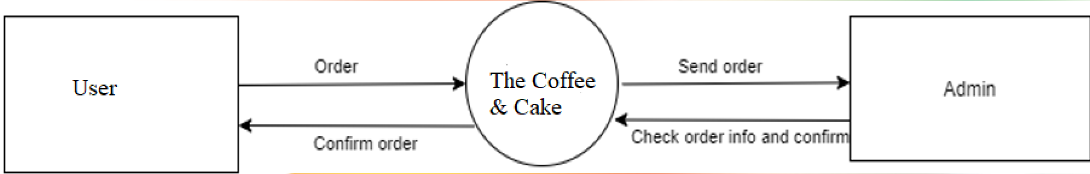

|  |
| --- |
| **A. Entity Relationship Diagram** |

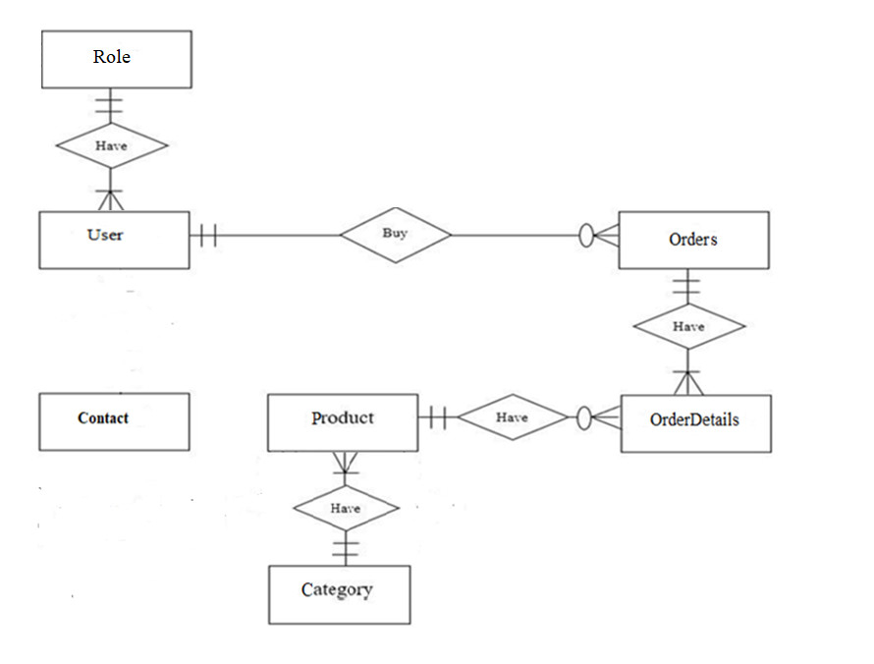

|  |
| --- |
| **B. Entity Attributes** |

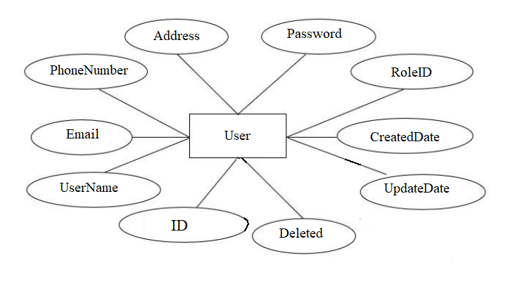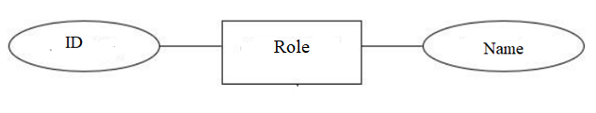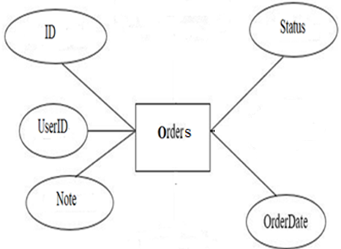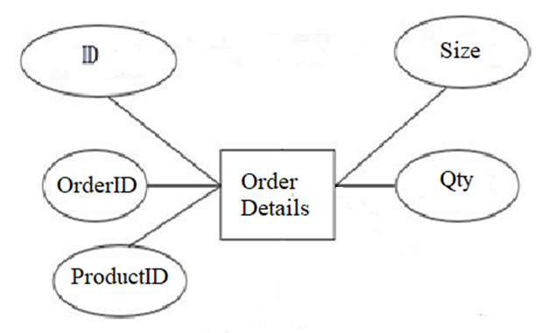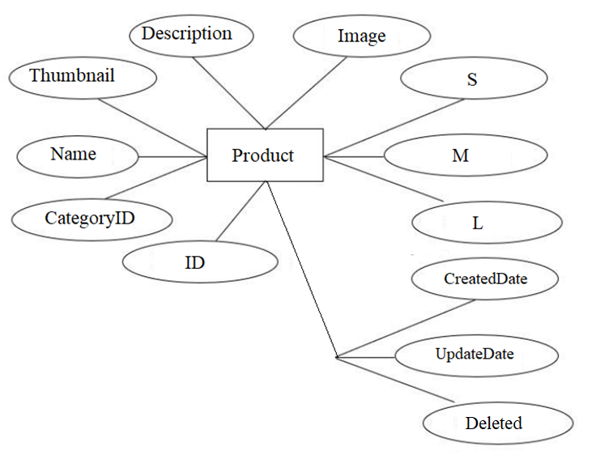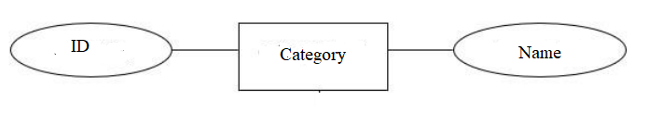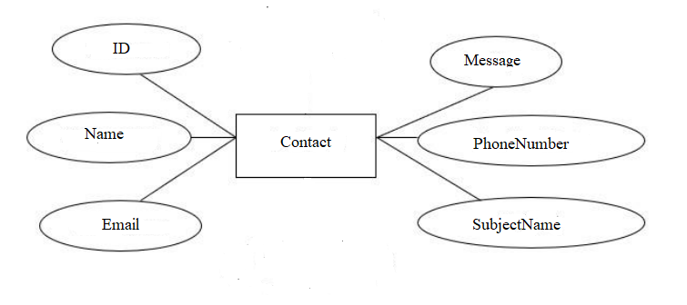

|  |
| --- |
| **A. Table Design** |

|  |  |  |  |  |  |
| --- | --- | --- | --- | --- | --- |
| **User** | | | | | |
| **Serial** | **Fields** | **Data type** | **Keys** | **Constrains** | **Description** |
| 1 | ID | int | Primary key, increment | Not null | ID identification |
| 2 | UserName | varchar(25) |  | Not null |  |
| 3 | Email | varchar(150) |  | Not null |  |
| 4 | PhoneNumber | varchar(13) |  | Not null |  |
| 5 | Address | varchar(200) |  | Not null |  |
| 6 | Password | varchar(32) |  | Not null |  |
| 6 | RoleID | int | Foreign key | Not null | Role ID identification |
| 7 | CreateDate | datetime |  | Not null |  |
| 8 | UpdateDate | datetime |  | null |  |
| 9 | Deleted | Boolean |  | Not null |  |

|  |  |  |  |  |  |
| --- | --- | --- | --- | --- | --- |
| **Role** | | | | | |
| **Serial** | **Fields** | **Data type** | **Keys** | **Constrains** | **Description** |
| 1 | ID | int | Primary key, increment | Not null | ID identification |
| 2 | Name | varchar(20) |  | Not null |  |

|  |  |  |  |  |  |
| --- | --- | --- | --- | --- | --- |
| **Product** | | | | | |
| **Serial** | **Fields** | **Data type** | **Keys** | **Constrains** | **Description** |
| 1 | ID | int | Primary key, increment | Not null | ID identification |
| 2 | CategoryID | int | Foreign key | Not null |  |
| 3 | Name | varchar(250) |  | Not null |  |
| 4 | Thumbnail | varchar(100) |  | Not null |  |
| 5 | Description | longtext |  | Not null |  |
| 6 | Image | varchar |  | Not null |  |
| 7 | S | int |  | Not null |  |
| 8 | M | int |  | Not null |  |
| 9 | L | int |  | Not null |  |
| 10 | CreateDate | datetime |  | Not null |  |
| 11 | UpdateDate | datetime |  | null |  |
| 12 | Deleted | Boolean |  | Not null |  |

|  |  |  |  |  |  |
| --- | --- | --- | --- | --- | --- |
| **Category** | | | | | |
| **Serial** | **Fields** | **Data type** | **Keys** | **Constrains** | **Description** |
| 1 | ID | int | Primary key, increment | Not null | ID identification |
| 2 | Name | varchar(100) |  | Not null |  |

|  |  |  |  |  |  |
| --- | --- | --- | --- | --- | --- |
| **Orders** | | | | | |
| **Serial** | **Fields** | **Data type** | **Keys** | **Constrains** | **Description** |
| 1 | ID | int | Primary key, increment | Not null | ID identification |
| 2 | UserID | int | Foreign key | Not null |  |
| 3 | Note | varchar(100) |  | Not null |  |
| 4 | OrderDate | datetime |  | Not null |  |
| 5 | Status | int |  | Not null |  |

|  |  |  |  |  |  |
| --- | --- | --- | --- | --- | --- |
| **Orderdetails** | | | | | |
| **Serial** | **Fields** | **Data type** | **Keys** | **Constrains** | **Description** |
| 1 | ID | int | Primary key, increment | Not null | ID identification |
| 2 | OrderID | int | Foreign key | Not null |  |
| 3 | ProductID | int | Foreign key | Not null |  |
| 4 | Size | varchar(2) |  | Not null |  |
| 4 | Qty | int |  | Not null |  |

|  |  |  |  |  |  |
| --- | --- | --- | --- | --- | --- |
| **Contact** | | | | | |
| **Serial** | **Fields** | **Data type** | **Keys** | **Constrains** | **Description** |
| 1 | ID | int | Primary key, increment | Not null | ID identification |
| 2 | Name | varchar(50) |  | Not null |  |
| 3 | Email | varchar(150) |  | Not null |  |
| 4 | PhoneNumber | varchar(13) |  | Not null |  |
| 5 | SubjectName | varchar(200) |  | Not null |  |
| 6 | Message | varchar(500) |  | Not null |  |

|  |
| --- |
| **B. Relationship Diagram** |

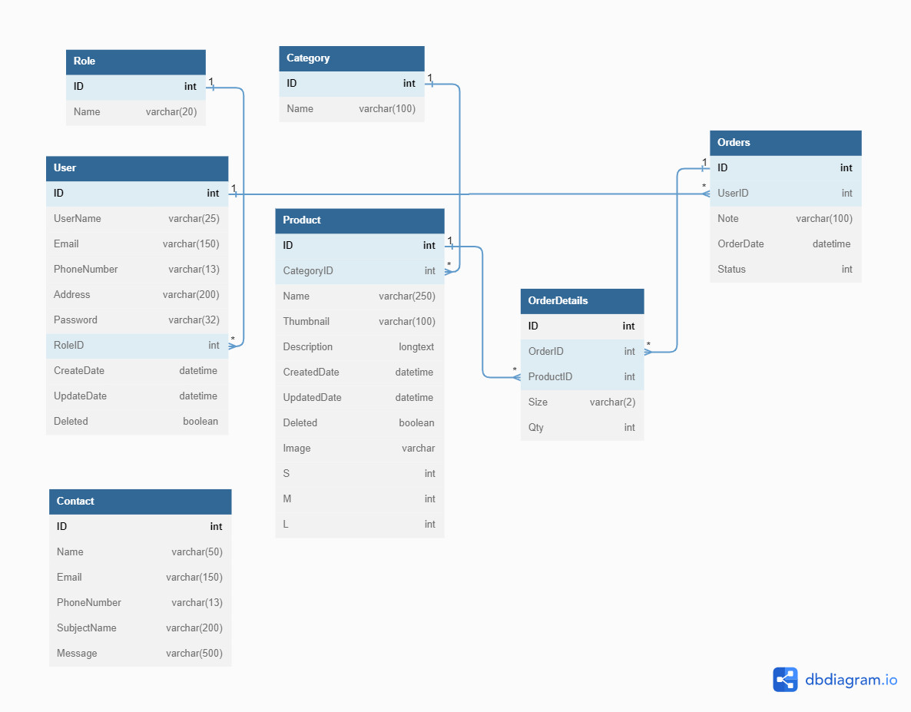

|  |
| --- |
| **SiteMap** |

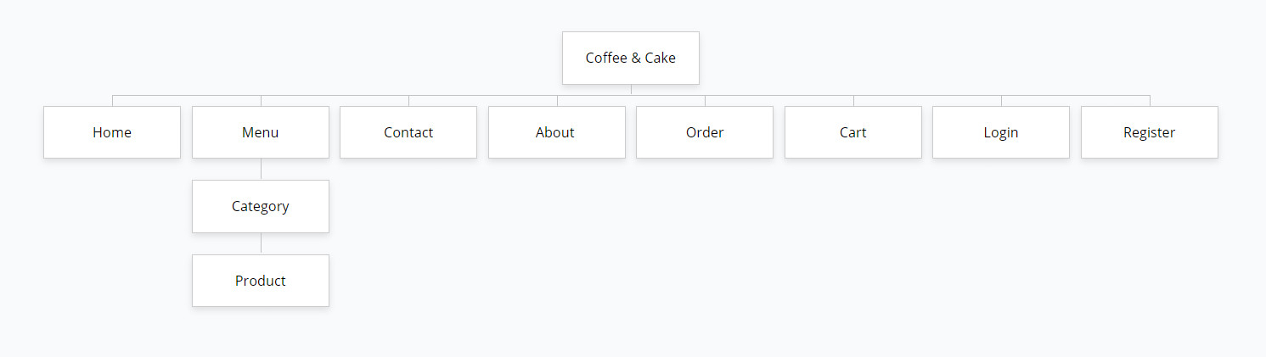

|  |
| --- |
| **Algorithm** |

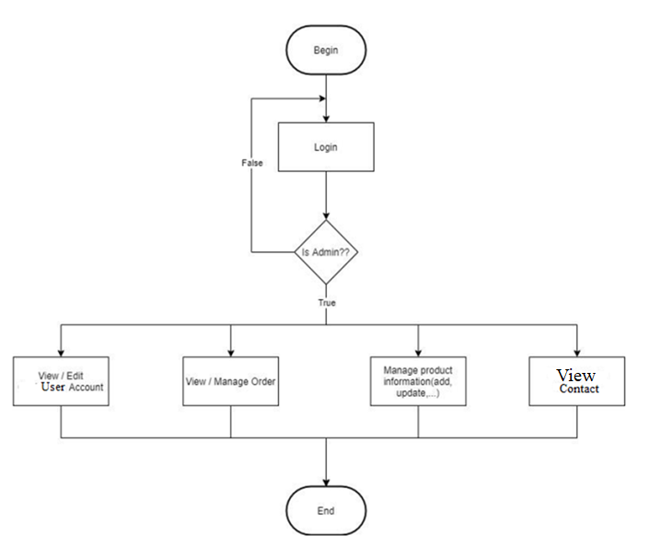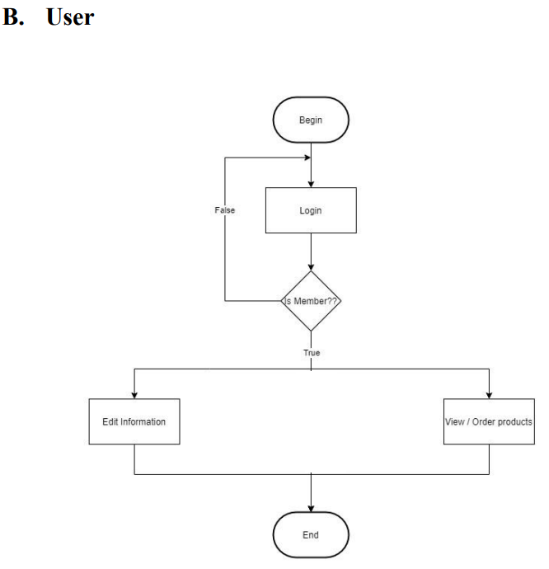

**Review 03**

|  |
| --- |
| **Screen shots** |

1. **Homepage:**

**1.Home**

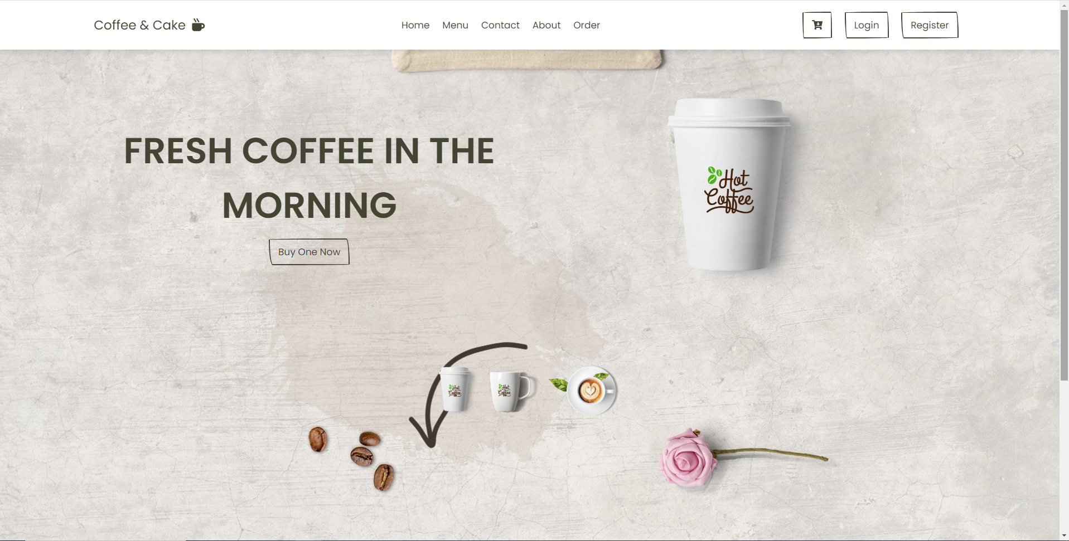

**2.Footer**

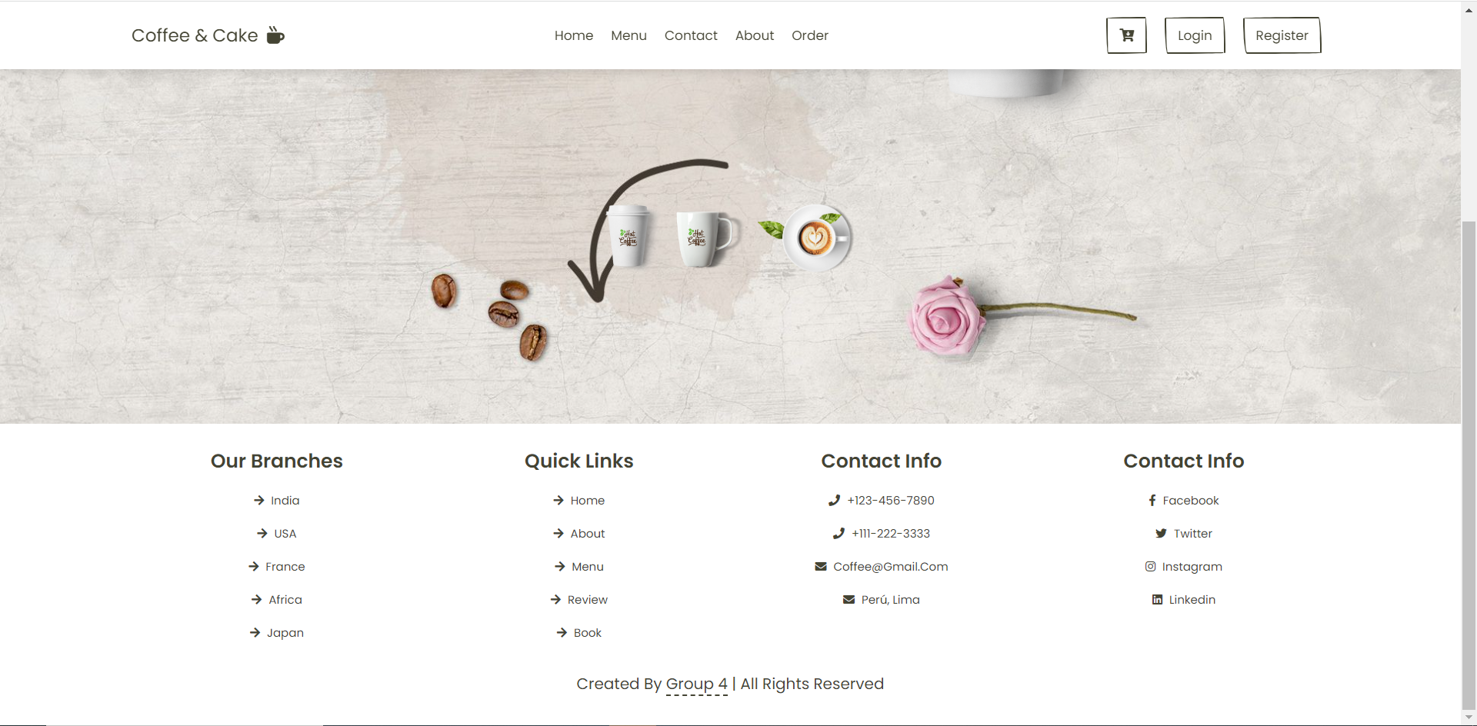

**Description** : This page is the Home Page of the Web. Used to introduce the Name and Content of the pages

**From** : Home, Logo.

**To** : Menu, Contac, About, Order, Cart, Login, Register.

1. **Menu**

**Description** : This page is for product description. Used to introduce the Name and Content of the product

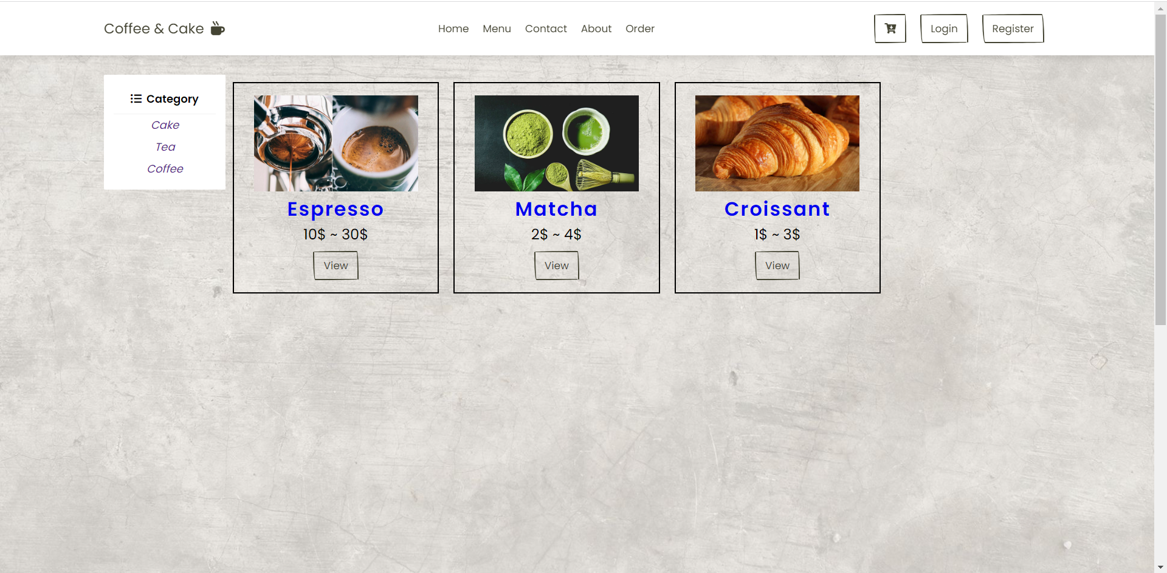

**From** : Menu.

**To** : Product Details.

1. **Contact**

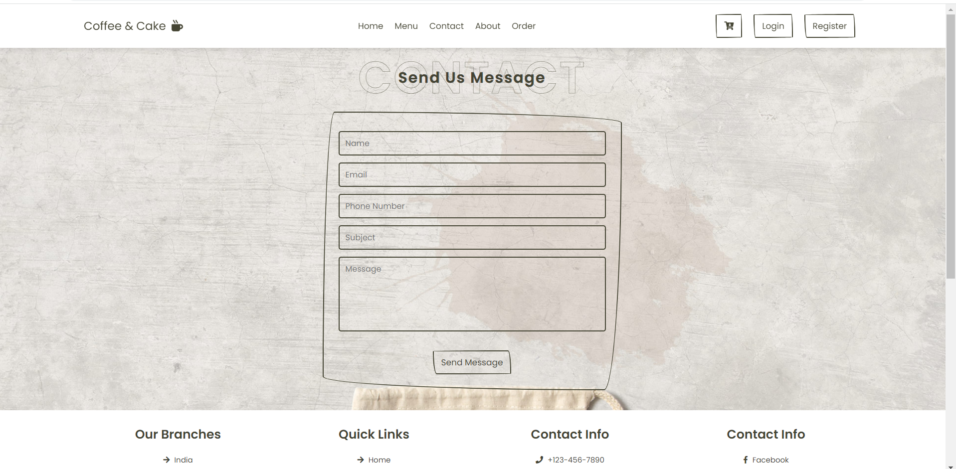

**Description** : This page is used to contact the Site Owner. Used to communicate between customers and web owners.

**From** : Contact.

1. **About**

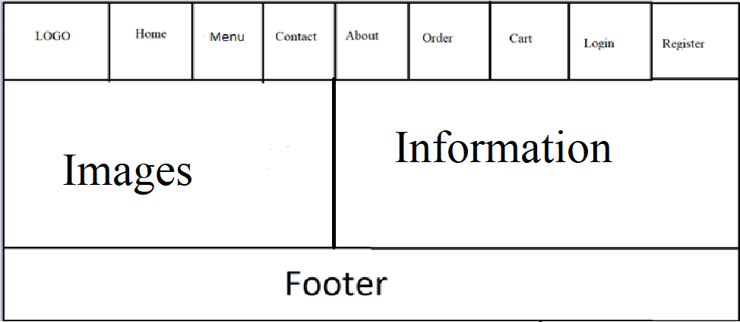

**Description** : This page is used to introduce information about webmasters...

**From** : About.

1. **Order**

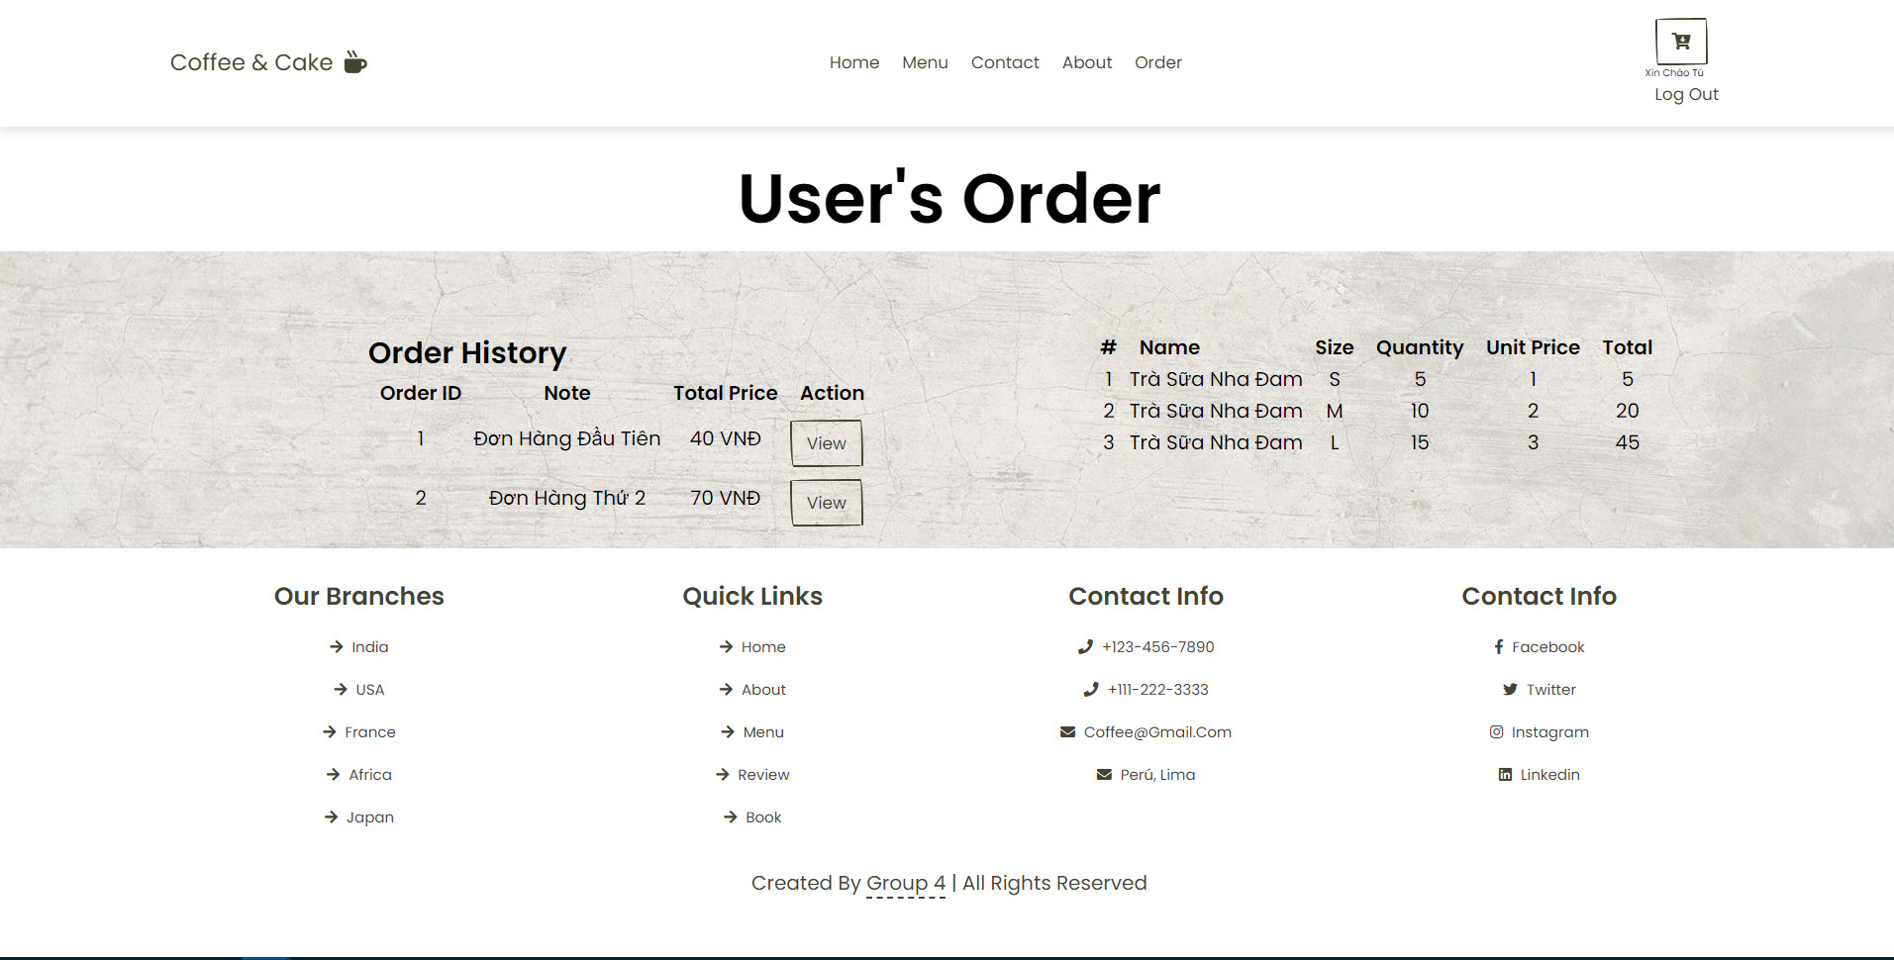

**Description** : This page is use for view the list of ordered products

**From** : Order.

1. **Cart**

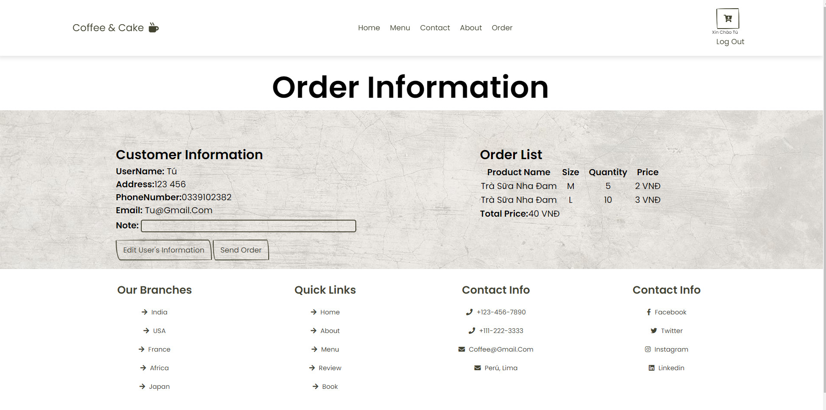

**Description** : This page is used to review the list of ordered products and submit comments

**From** : Cart.

1. **Login**

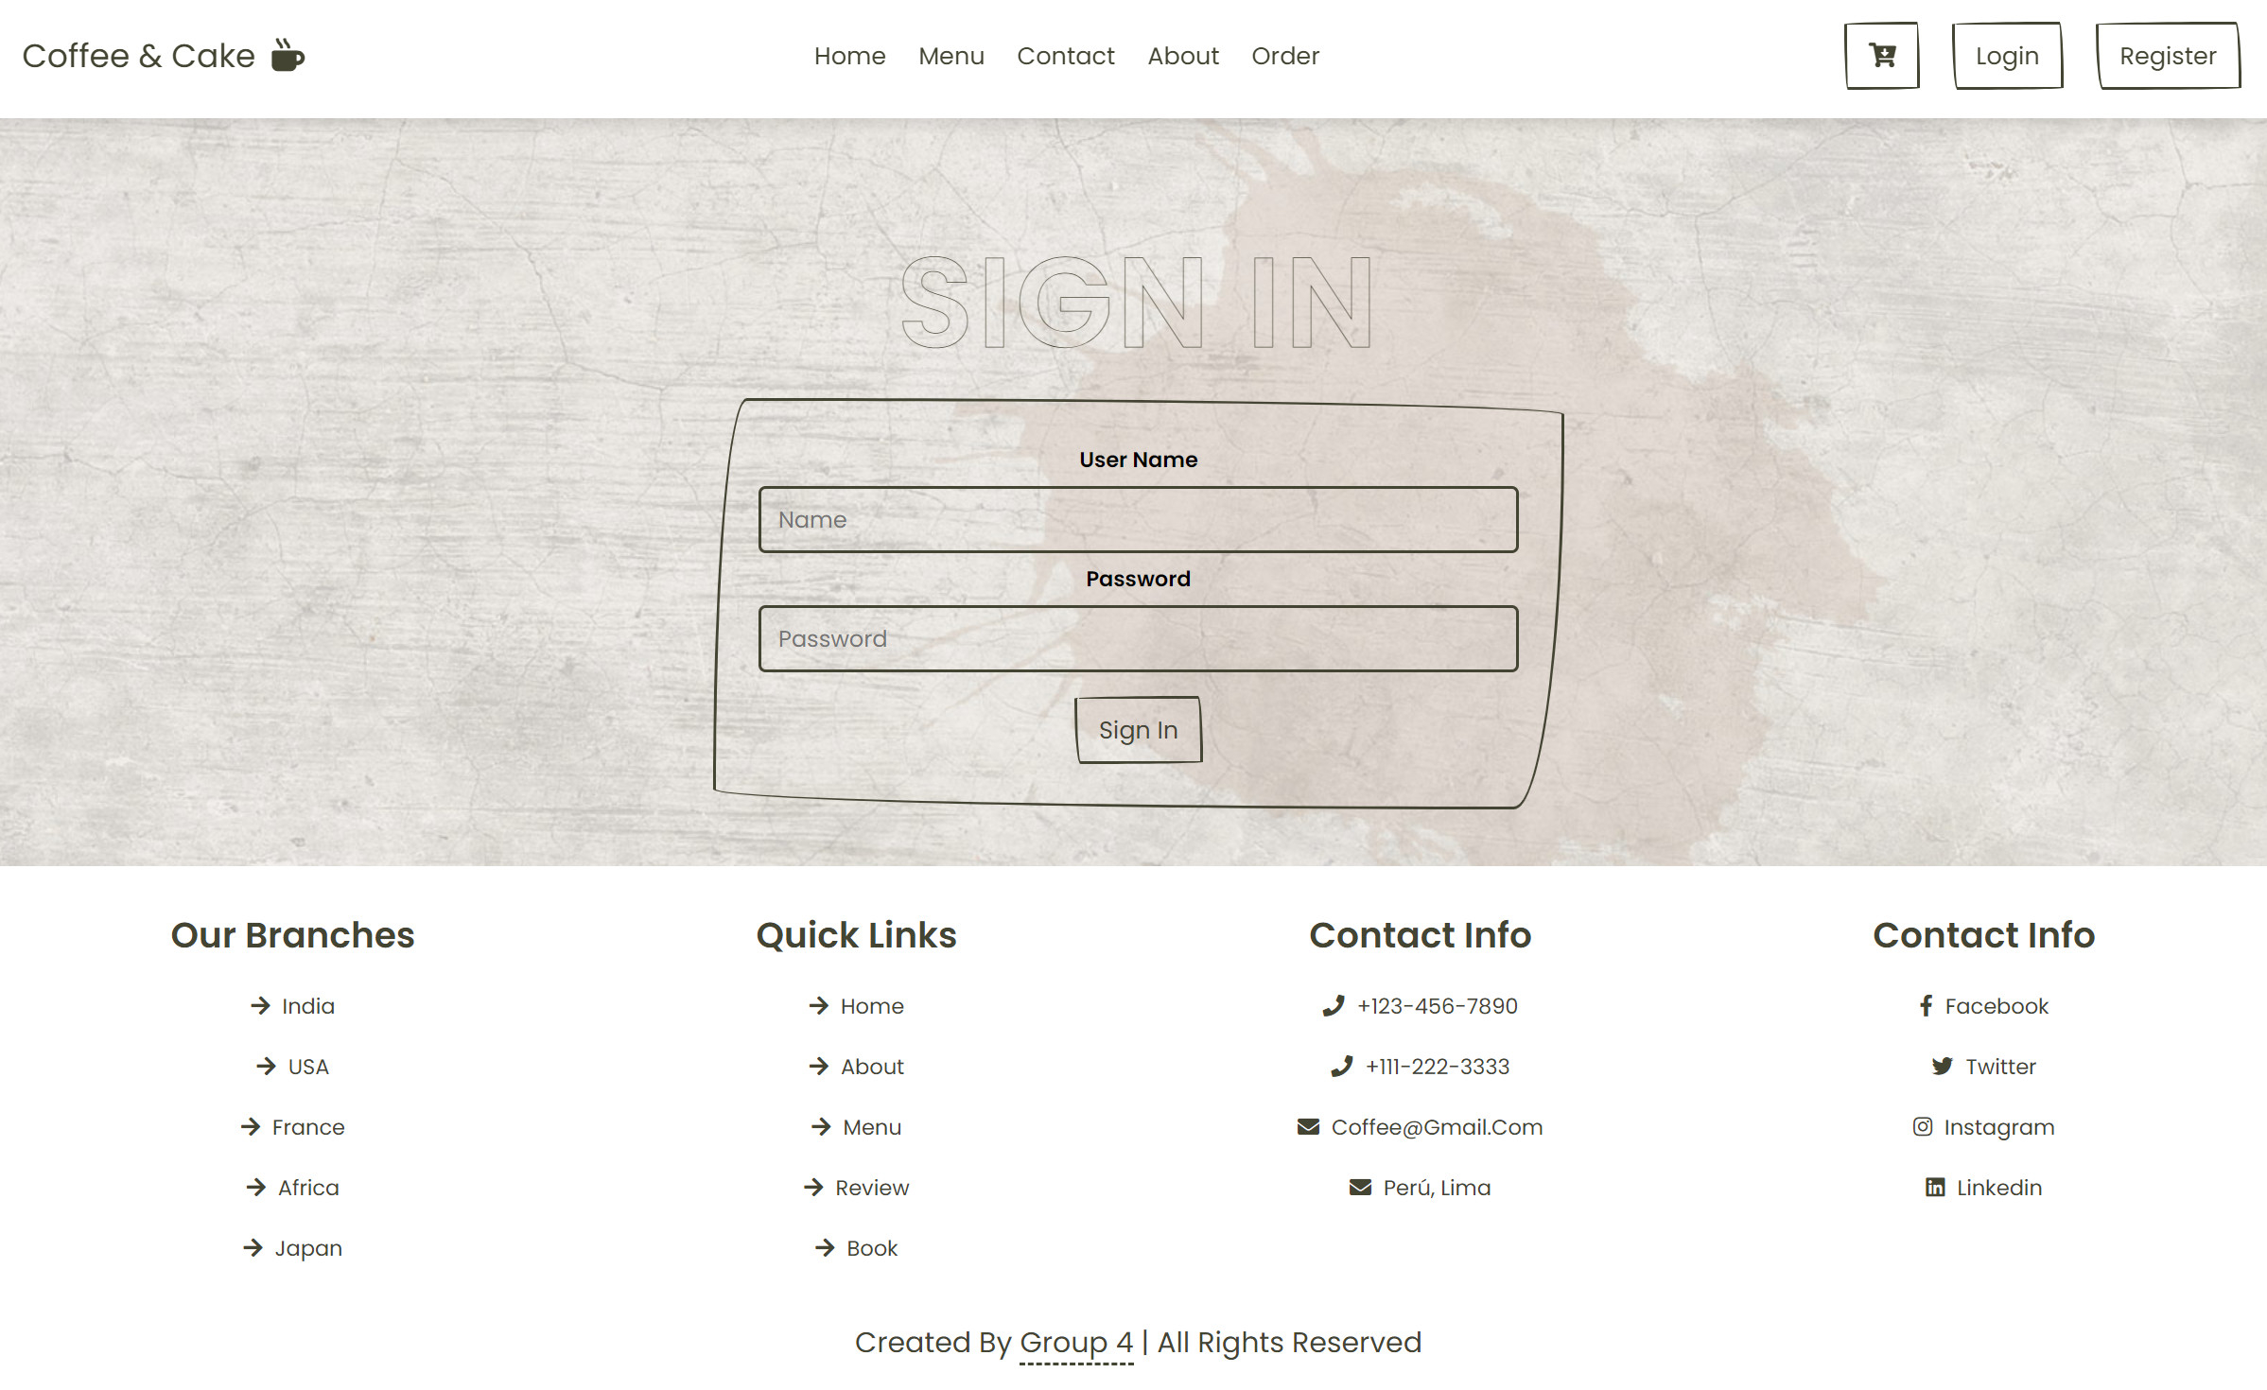

**Description** : This page is for login

**From** : Login

1. **Register**

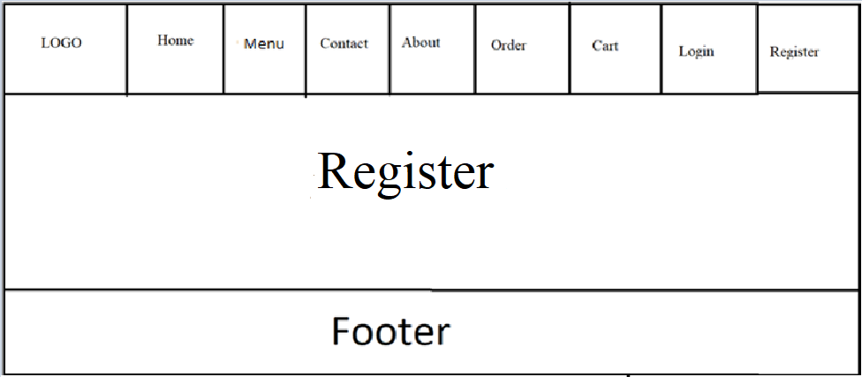

**Description** : This page is for Register

**From** : Register

|  |
| --- |
| **Testing document** |

|  |  |  |
| --- | --- | --- |
| **Sr.No** | **Features Tested** | **Remarks** |
| 1 | Can users register and log in to their accounts? | Yes |
| 2 | Can the user view the product? | Yes |
| 3 | When the user logs in, does it go to the user's page? | Yes |
| 4 | When logged in admin, do you have access to the admin page? | Yes |
| 5 | If a customer places an order, will it be added to the cart? | Yes |
| 6 | When you click pay, will the order be sent to the admin for approval? | Yes |
| 7 | When clicking "view", can the user see the product details? | Yes |
| 8 | Can customers choose the size and quantity of products? | Yes |

|  |
| --- |
| **Final checklist** |

|  |  |  |
| --- | --- | --- |
| **Sr.No** | **Aspected Tested** | **Suggestion/**  **Remarks** |
| 1 | Are all the users able to view the images ? | Yes |
| 2 | Have all the views, modules and controllers been properly integrated and is the site function as a single page application? | Yes |
| 3 | Are the GUI content devoid of spelling mistakes? | Yes |
| 4 | Is the application user-friendly? | Yes |
| 5 | Is the Website launching correctly in all popular browsers? | Yes |
| 6 | Are all the forms validated with proper criteria? | Yes |
| 7 | Do all text links lead to the appropriate website? | Yes |
| 8 | Do all image links lead to the appropriate website? | Yes |
| 9 | Are all the images and links clearly visible on the page? | Yes |
| 10 | Does the Web page work properly in all the tested browsers? | No |
| 11 | Does the Web page take too long to be loaded fully? | Yes |
| 12 | Is the navigation sequences correct through all the Web pages on the site? | Yes |

|  |  |  |  |  |  |  |  |  |
| --- | --- | --- | --- | --- | --- | --- | --- | --- |
| **No** | **Member** | **Content** | | **Table Name** | **Activity Plan** | **Date of Preparation of Activity Plan** | | |
| **Planed Start Date** | **Actual Start Date** | **Actual Days** | **Status** |
| 1 | **Trần Lê Huy** | Admin | *Customer Management*  *View Contact* | User | Contact | 21/03/2023 | 04/04/2023 | 15 | Done |
| 2 | 21/03/2023 | 04/04/2023 | 15 | Done |
| 3 | User | *Register* | 21/03/2023 | 04/04/2023 | 15 | Done |
| 4 | *Send email contact* | 21/03/2023 | 04/04/2023 | 15 | Done |
| 5 | *Personal Account Management* | 21/03/2023 | 04/04/2023 | 15 | Done |
|  | | | |  |  | | | |
| 1 | **Nguyễn Đình Nam** | Admin | *Product Management* | Product | 21/03/2023 | 04/04/2023 | 15 | Done |
| 2 | 21/03/2023 | 04/04/2023 | 15 | Done |
| 3 | 21/03/2023 | 04/04/2023 | 15 | Done |
| 4 | User | *View Product* | 21/03/2023 | 04/04/2023 | 15 | Done |
|  | | | |  |  | | | |
| 1 | **Trần Hoàng Tú** | Admin | *Order Management* | User | Order | 21/03/2023 | 04/04/2023 | 15 | Done |
| 2 | 21/03/2023 | 04/04/2023 | 15 | Done |
| 3 | User | *Add Order* | 23/03/2023 | 04/04/2023 | 15 | Done |
| 4 | *Sign in / Log out* | 29/04/2023 | 04/04/2023 | 15 | Done |
| 5 | *Personal Order Management* | 23/03/2023 | 04/04/2023 | 15 | Done |